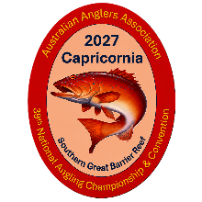
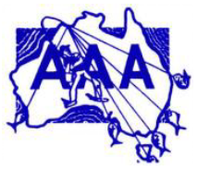
Australian Anglers Association 2027
39th National Convention & Championship Capricornia – 17th May to 29th May 2027
Nomination Form
Early Bird Discount: Entries received by 17 March 2027 receive a $5 discount. Email completed form to: treasurer@qafca.com.au
Payment Details Reference: Your Surname
Direct Deposit:
Account Name: QAFCA
BSB: 034-080
Account No: 637954
A confirmation email will be sent once your nomination and payment have been received.Competitor Details
Name: _______________________________________________
Address: _____________________________________________
Affiliated State: _______________________________________
Phone: _______________________________________________
Email: ________________________________________________
Date of Birth (Juniors/Veterans): ____ / ____ / ______Events (tick all that apply) ☐ Estuary ☐ Offshore ☐ Rock & Beach
☐ Casting ☐ SocialCompetition Category (tick one), the below amounts are the full cost:-
☐ Men's – $80 ☐ Veteran Men's (60+) – $80
☐ Ladies – $80 ☐ Veteran Ladies (60+) – $80
☐ Junior (Under 17) – $35 ☐ Social (Non-Competitor) – $35Eligibility
- Veterans: Must be 60 years or older on or before 17 May 2027.
- Juniors: Must be under 17 years of age on 17 May 2027.
- Juniors must have this form signed by a parent or guardian.

Competitor Signature: ____________________________ Date: ____ / ____ / ______
Parent/Guardian Signature (Junior only): ________________________________

