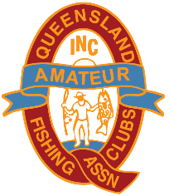
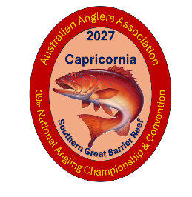
Queensland Amateur Fishing Clubs’ Assoc Inc.
Email: secretary@qafca.com.au
Australian Anglers Association 2027
National Convention & Championship Capricorn Coast – Kinka Beach
Proposed Program
Monday 17th May 2027 to Saturday 29th May 2027
Headquarters – Discovery Parks Coolwaters Yeppoon, 760 Scenic Highway, Kinka Beach
Monday 17th May 2027  Registration Headquarters 1pm to 5pm  Boat Inspections from 1pm to 5pm | Monday 24th May 2027  Registration 4.30am  1st Round Estuary 6am to 12pm  Weigh In 3.00pm
Tuesday 18th May 2027  Registration Headquarters 9am to 1pm  Boat Inspections from 9am to 1pm  Civic Reception 12pm  Opening Ceremony 4pm  Old Friends Night following | Tuesday 25th May 2027  Registration 4.00am  2nd Round Offshore 6am to 12pm  Weigh In 3.00pm
Wednesday 19th May 2027  Registration 4.00am  1st Round Offshore 6am to 12pm  Weigh In 3.00pm | Wednesday 26th May 2027  Lay Day
Thursday 20th May 2027  1st Round Casting at Kalka Shades Birdwood Park - Kalka Shades Cricket Grounds, 8am | Thursday 27th May 2027  Registration 4.30am  2nd Round Estuary 6am to 12pm  Weigh In 3.00pm
Friday 21st May 2027  2nd Round Casting at Kalka Shades Birdwood Park - Kalka Shades Cricket Grounds, 8am | Friday 28th May 2027  Registration 4.30am  2nd Round Rock and Beach 6am to 12pm  Weigh In 3.00pm
Saturday 22nd May 2027  Registration 4.30am  1st Round Rock and Beach 6am to 12pm  Weigh In 3.00pm  Available for “State Night” | Saturday 29th May 2027  Convention Meeting 9.00am  Presentation 4pm  Presentation Dinner at 6pm
Sunday 23rd May 2027
Lay Day
AGM / Federal Executive Meeting 9.00am

Rock & Beach Boundary - Coconut Point to Fishing Creek.
Estuary – Fitzroy River, Corio Bay, Coorooman Creek
Offshore – Yeppoon

Queensland Amateur Fishing Clubs’ Assoc Inc.
Email: secretary@qafca.com.au

Headquarters will be open daily and available for activities.
Suggestions for Social Days: -
- Byfield, Nobbs Creek Pottery, Stoney Creek, Ferns Hideaway, Byfield Store
- Capricorn Caves
- Great Keppel Island
- Koorana Crocodile Farm
- Day Trip around the Capricorn Coast
- ANZAC Memorial Walk Emu Park
- Rockhampton Zoo and Botanic Gardens
- Rockhampton Museum of Art
- Rockhampton Heritage Village

High Tea at Headquarters
Morning Tea or Lunch at Footlights Theatre
Paint and Sip Afternoon
Resin Art Class
Trivia Night – Come dressed as your Best Catch
Fish Fry
Mini Golf
Scavenger Hunt
Progressive Dinner
Potluck dinner on the last night of competition

